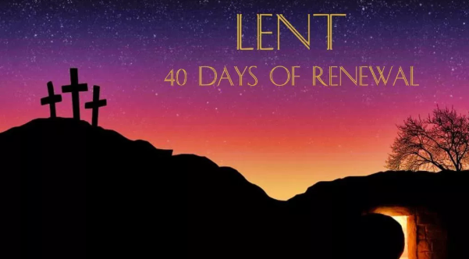
Prayer/Act of Worship Resource
Week Beginning: 10th March 2025
Theme: Faithful in everything.

Reflection: “Our prayer and fasting will be a plea for peace in our world, remembering that world peace always begins with our personal conversion.” Pope Francis
Readings: Deuteronomy 26:4-10; Psalm 90: Romans 10:8-13; Luke 4:1-13

“Never mind the threat of nuclear war, what about the rise in electric and gas bills, not to mention the latest: - The price of petrol is going through the roof! And will there be more taxes, if we go to war?” The conversation at the check-out very swiftly moved on from the plight of the people in the Ukraine to personal money concerns. Following the election of a new President in the USA there have been news bulletins that have included political experts expounding the belief that ‘the West’s priority must be to win the economic confrontation with Russia.’ Is it really money that makes the world go round? Are our only values economic ones? Whilst this can often be a ‘temptation’; we know that there has been a global outpouring of a desire for peace in the Ukraine, the Middle East and throughout the world that would see an end to suffering for our sisters and brothers.

There are many temptations in our modern world, where success is often measured by ‘economic’ fortune (and fame). On the First Sunday of Lent we remember how Jesus, despite temptations, kept God’s highest commandment: ‘You shall love the Lord your God with all your heart, with all your soul, and with all your strength.’ ‘With all your heart‘(with total determination). ‘With all your soul‘(loving and serving God our whole life long) ‘With all your strength‘ (putting all of ourselves at God’s disposal). The love of Jesus for God and God’s people was total; but this does not mean that it was any easier for him to practice than it is for us. He too had to struggle to choose between God and self. The tension of it is spelled out in the dramatic story of the temptations Jesus faced during his time of prayer in the desert. There he spent forty days working out the meaning of his life, trying to figure out what God wanted of him. In the process, he came face to face with certain fundamental choices.

First, the tempter suggests to Jesus, who was hungry after fasting: ‘If you are the Son of God, tell this stone to turn into a loaf of bread.’ In other words, use your power and influence, not for others but for your own satisfaction, comfort and convenience. Though Jesus is desperate for something to eat, he will not dally with this desire, even for a moment. Instead, he seeks nourishment of a different kind, relying on God’s clear message: ‘One does not live on bread alone.’

That was one kind of temptation, but the idea that next presented to Jesus is even more subtle and appealing. This is to use his intelligence and his charisma to gather round him the rich and powerful from every nation, and, eventually, to become a great political leader. It was the temptation to seek world attention and become a political messiah, a temptation to fame and fortune and empire building. This attraction is the very opposite of what God has said in Scripture about his chosen servant, the saviour of the world’s poor and marginalised. God clearly means his Messiah to be a humble servant, a suffering servant, one who sacrifices his life in love. Jesus remembers this, realizes this, and takes it to heart. Therefore, he blitzes the temptation with another clear and definite command of God in Scripture: ‘You must worship the Lord your God, and serve him alone.’

The third temptation (according to Luke) is to go to the very top of the temple in Jerusalem and take a flying leap from there. A stunt like this will surely attract new followers, and prove to Jesus personally whether God cares about him or not. The very thought of it is fascinating. Jesus, however, promptly puts the idea completely out of his mind as he remembers and relishes God’s word: ‘You must not put the Lord your God to the test.’

During his temptations, Jesus was weak with hunger, but he still held firm. He had not eaten for many days, but he still said “No.” What mattered to him was to do the will of his heavenly Father. He treasured the word of God and was determined to live by it. Each of the temptations pointed to some selfish option that was contrary to his real mission. In each case, he resisted, to be faithful to God. A source of strength for all of us is the knowledge that Jesus in his humanity overcame temptations and was strengthened to face the greatest temptation that would face him in the Garden of Gethsemane where he was able to say “Yes” to the will of God. It’s worth noting that the Holy Spirit led Jesus into the wilderness and as difficult as that wilderness was he emerged a new man ready to be ever faithful and embrace his Father’s will. We too are being led by the Holy Spirit through our own wilderness to seek the hand of God for guidance, and by the gift of grace we too can say ‘No’ to temptations and a faithful ‘Yes’ to God’s desire for us.

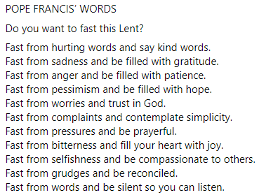
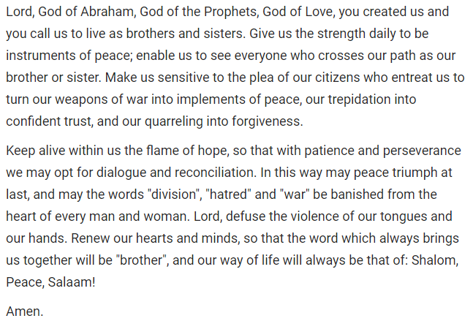
Words from Pope Francis for Sharing

Prayers
The response and prayers this week is: Father, we faithfully place our prayers for Peace before you. (Amen)
Monday: We pray that the Church may show the world the way to God and the way to Peace through repentance, fasting and prayer R/.


Tuesday: We pray that world leaders may work together to seek peace and justice for all R/.

Wednesday: We pray that as God made a covenant with all living things, so we may grow in our respect for life, and actively protect it R/.

Thursday: We pray that those who are refugees may be welcomed by others with compassion R/.

Friday: We pray that those who have died may dwell with the angels and saints forever “in the shelter of the Most High,” R/.

