Gatsby Benchmarks… working towards

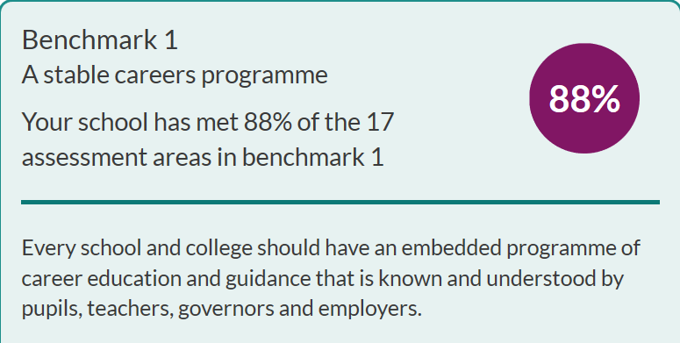

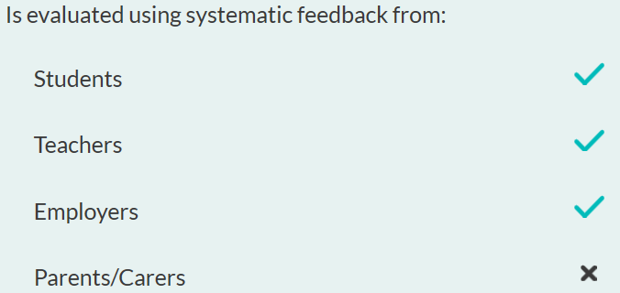

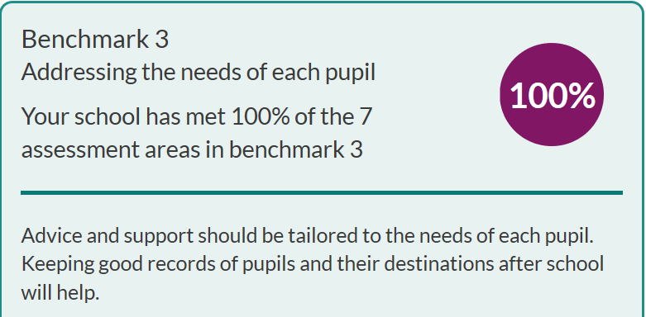

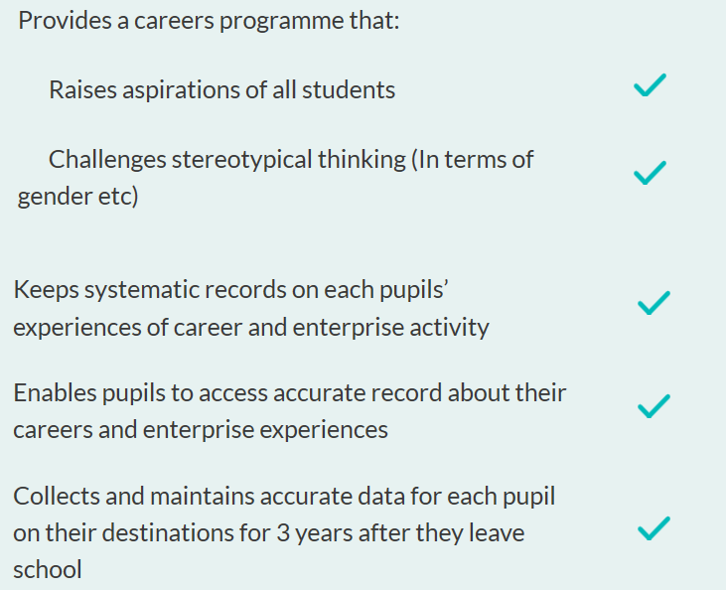

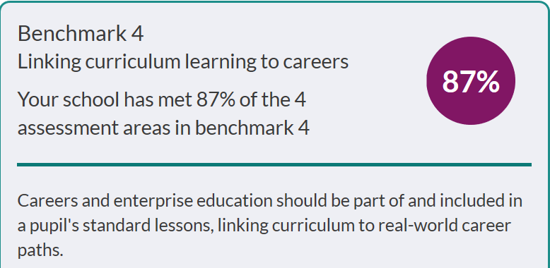

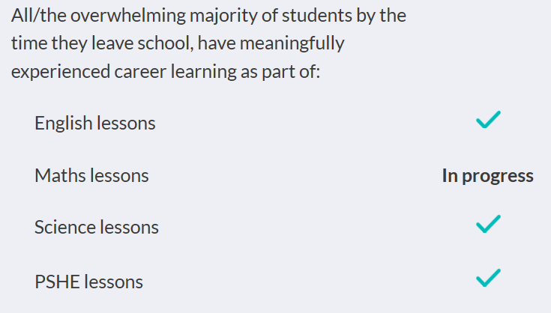

Careers & IAG

Year Groups
Year 7 | Year 8 | Year 9 | Year 10 | Year 11 | Sixth Form
Unilever Science Day | Science Fair | Options Evening | One-to-one career guidance talks–with Careers Advisor | Presentations from external providers:  - Lockhead Martin presentation  - Finance and Accounting  - National Citizenship Service  - Applying to Law  - Atlas Engineering  - Amazing Apprenticeships  - National Citizenship Service  - SEMLEP Careers Broadcasts | Presentations from external providers:  - Lockhead Martin presentation  - Finance and Accounting  - National Citizenship Service  - Applying to Law  - Atlas Engineering  - Amazing Apprenticeships  - National Citizenship Service  - Russell Group applications  - Vision Learn  - SEMLEP Careers Broadcasts
Think Tank (Birmingham) | Big Bang (Birmingham) | Passport to University UOB programme | Work Experience: DEVELOP  Health & Social Care | St Thomas More Careers Fair  External providers of apprenticeships, HE and employment | St Thomas More Careers Event  External providers of apprenticeships, HE and employment
Priesthood/ youth worker workshop |  | Spring Residential (UOB) | Unifrog launch | SEND  - Support with applications  - College open evening | UCAS/Apprenticeship programme
Kidzania (London) |  |  | St Thomas More Careers Event  External providers of apprenticeships, HE and employment | One-to-one career guidance talks with  - Careers Advisor  - Sixth Form Team | One-to-one career guidance talks with  - Careers Advisor  - Sixth Form Team
 |  |  | Car Crash Careers  Health and Social Care | Health & Social Care Academy | University of Bedfordshire Convention Day  Festival arranged by the UOB at the UOB
 |  |  |  | Visit to Bedford Hospital  Pathology Department | External visits  - Careers event at Bedford Modern
Parents Information Evenings
- UCAS
- Next Steps
- Apprenticeships
Summer Schools
- Sutton Trust
- Bedford University Summer school-
- Nursing
- Nuffield Research Placements

Alumni visits

Accountancy & Finance

IT Security (Santander)

University of Oxford
Volunteer work/work experience
Bedford Hospital
Primary schools/Child Care providers
Kimbolton Lodge
BDRS- Bedford Disabled Riding School
 |  |  |  |  | Health & Social Care Academy

Next Steps:

- Year 9 – whole year group event- ‘take your child to work day’
- Year 9 – Options Evening to include a Careers Event
- Year 9 – ‘Step up to Uni’ programme
- Introductory ‘pathway’ (apprenticeship/university) sessions for Year 7, 8 & 9
- Year 10- Oxbridge Visit
- Launch Unifrog with KS3
- World of Work Wednesdays
- Worktree – ‘Meet the Professional’ speed dating
- Consider alternatives to Careers Advisor presence at Parents’ Evenings
- KS5 BTEC courses to include work experience

Careers & IAG

Departments
Maths | Science | English | Technology
- Links with KPMG (KS4&5) | - Think Tank Trip (KS3)  - Salters' Festivals of Chemistry  (Cambridge University) (KS3)  - Science Fair (KS3)  - O’real Young Scientist (KS3)  - RBS Biology Challenge (KS4)  - Shepreth Wild Life Park (KS4)  - British Science Week (KS3,4&5) | - Visiting Authors

Next Steps:

- Work collaboratively with HODS to create opportunities within key subject areas
- Review Careers section of Curriculum Plans – employability skills
- Use of destination data within subject areas to help shape careers guidance
- Subject ‘career ambassadors’

PSHE overview
Year Group | Focus | Autumn Term (2) | Summer Term (2)
Year 7 | Explore students’ interests and motivations and develop a broad understanding of world of work. | Living in the Wider World.  Focus: Enterprise skills and introduction to careers. Challenging career stereotypes and raising aspirations. | Living in the Wider World.  Focus: Making ethical and financial decisions. Saving, spending and budgeting our money.
Year 8 | Explore further students’ interests and motivations and start to build up a profile of skills, talents and qualities that they can build upon. | Living in the Wider World.  Focus: Evaluating value for money in services. Risks and consequences of making financial decisions. | Living in the Wider World.  Focus: Rights and responsibilities in the community. Tackling age and disability discrimination.
Year 9 | Focus on building career aspirations and exploring a variety of career pathways and opportunities. | Living in the Wider World.  Focus: Careers and Values; developing qualities and skills.  Use of websites such as Talking Jobs, UCAS (The Buzz Quiz), Explore Job families. | Living in the Wider World.  Focus: Reflecting on learning skills development in Key Stage 3.
Year 10 | Address self-presentation and explore the variety of skills and qualities employers are looking for. | Living in the Wider World.  Focus: Understanding the causes and effects of debt. | Living in the Wider World.  Focus: Preparation for work. Develop employability skills and relate learning to the world of work.
Year 11 | Support with practical plans and guidance when making decisions and applications for post-16 learning. | Living in the Wider World.  Focus: Understanding the College/ Sixth Form application process and plans beyond school. Skills for employment and career progression.

