
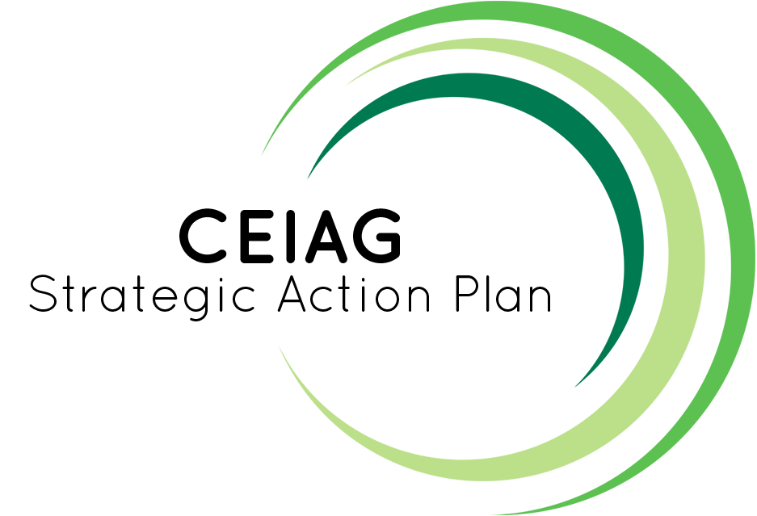

Careers Education Information Advice Guidance

Approved by: | Headteacher |  | Date: | Sept 2023
Last reviewed on: | July 2023
Next review due by: | July 2024

Vision

At St Thomas More, students have the opportunity to acquire the skills, qualities and knowledge required to pursue a future pathway that is right for them. All students will achieve their true potential whilst being fully prepared for their transition into the ever changing world of work.

The intent of our Careers Curriculum is to provide a stable careers programme where all students are provided with the opportunity to prepare for their transition into the world of work. We intend to raise their aspirations, improve social mobility, develop 8 employability skills and enhance knowledge of labour market information whilst providing them with the access to all career pathways. Students will experience a range of encounters tailored to their individual needs and circumstances which will include encounter of workplaces, employers, an insight into further and higher education establishments and opportunities for personal guidance.

Strategic Objectives
Objective 1 - Promote and increase careers education in the curriculum across all year groups.

Benchmarks: 2, 3, 4, 7
- Encourage all staff to work in their departments to lead CEIAG initiatives in their subject areas.
- All tutors to share careers, activities and videos on World of Work Wednesdays.

Objective 2 - Increase student and parental involvement and confidence in career planning.

Benchmarks: 2, 3, 6
- Post 16 and post 18 pathways through termly events and meetings e.g. information sessions via coffee mornings and parents information events and looms. A careers newsletter highlighting opportunities and vacancies.
- A physical work experience/virtual work experience board to be set up. Information from the borough, SEMLEP, Speakers for Schools, Pathway CTM and Uptree. Replicated via Firefly and shared as a task with parents and students.
- Record keeping to be improved by teachers and students on Unifrog exposures and interactions.

Objective 3 - Develop a programme of encounters to meet the individual needs of all students by creating a network of employers and educational providers to support learning.

Benchmarks: 3, 4, 5, 6
- Continue to develop an ALUMNI of support.
- Continue to develop links with organisations and build on existing relationships
- Network and make contact with other Universities other than Bedfordshire for on site visits, taster days and shadowing days.

Current State
Staffing includes one full time member of staff who is on SLT and in charge of personal development who has overall responsibility as Careers Leader for the school. There are two other support staff who are qualified in careers advice. One member of staff is the 6th form Admin Assistant who uses two of her days on whole school careers advice and the other is the 6th form Centre Study Manager who completes one day a week a week on careers and picks 6th form students up in an ad hoc way when supervising in the study centre.
From September 2023 onwards, as a PDR objective, we are asking most staff to have an enrichment target which could include careers champions within their department to embded careers within their department/curriculum. With a member of SLT as the Careers Lead, SLT fully support the development of CEIAG at St Thomas More which aims to raise the aspirations of ALL students. See Apprendix 2 as to where the school stands at present.

In order to create our development plan a SWOT analysis was carried out see Appendix 1. We are working hard towards embedding Careers throughout the school. We are part of SEMLEP and have achieved 3-4 of the Gatsby Benchmarks in July 2023 and working towards achieving the full eight by November 2023. Careers has been introduced into the curriculum in all year groups. Year 7 and 8 started their induction to Unifrog with a careers treasure hunt. Careers breakfasts in Key stage 4 have been a welcome addition to Friday which only use our school Alumni to deliver so students can aspire to be like them. Future Fridays has had a soft launch but it is not being utilised fully. We will launch World of Work Wednesdays for each year group in September and pastoral leads will do learning walks to ensure a consistent message is being delivered whole school re the career highlighted on the World of Work scheme of work.

Destination Data

Last year our year 11 pupils moved to range of providers in the local area after school:
- 55% stayed with St Thomas More
- 11% left to attend Bedford 6th Form
- 10% left to attend Bedford College
- 4% left to attend Kimberley college
- 2% left for an apprenticeship
- The other 18% left to attend other schools or moved out of the area

Last year our year 13 pupils moved to range of providers in the local area after school:
- 55% of our students went to University
- 11% of students deferred their application and took a gap year
- 10% of students went onto an apprenticeship
- 6% of our students went straight into employment
- 13% of our students went onto college

Areas for development:
- Continue to develop an ALUMNI of support – to help support Benchmarks 3, 6 & 7.
- Create and publicise careers related work in school– to help support parental engagement and LMI Benchmark 2. Use Firefly, a newsletter, opportunities available for students- trips, work experience, taster events etc
- Offer greater support for those applying for apprenticeships focussing on those weaker learners applying for University as not sure what else to do (Benchmarks 3 & 8).
- Embed more careers information into Key stage 3 PSHE

Action Plan

Strategic Objective 1
Promote and increase careers education in the curriculum across all year groups.
Benchmarks: 1, 2, 3, 4, 7
 | Targets | Actions
Year  0ne  2023  -  2024 | Encourage all departments to lead CEIAG initiatives within their subject areas.  Unifrog introduced to the whole school  Ensure World of Work tutorial sessions are being delivered consistently school wide  All PSHE schemes of work to have a World of Work section with scheme of work that progresses on from the previous year. | Careers Champions to create activities for years 7-9 which reference careers and Labour Market Information (LMI).  Quizzes re where to find things on Unifrog. Planning to incorporate careers.  Staff receive CPD on CEIAG and Unifrog  Careers Lead/Pastoral Lead Monitoring
Year  Two  2024  -  2025 | Departments implementing CEIAG initiatives in their subject areas- enrichment, trips, visits  All students have had a one to one careers interview by the end of Year 10 | Staff are talking about careers in lessons.  Appoint careers champions to lead on subject projects relevant and create links with businesses.  Careers Leader keeps records and instructs careers advisor re year groups and priority re cohort sub groups
Year  Three  2025  -  2026 | Departments take ownership of careers delivery, keep their own Alumni records to liaise with previous students and use 6th form ambassadors to facilitate learning  Unifrog fully up to date with activities and exposures | Student voice and learning walks demonstrate lessons are developed to incorporate LMI and Unifrog competencies  Students have access to wealth of experiences and exposures to make informed careers based decisions. Interactions prove skills development for job, University or apprenticeship applications.
Strategic Objective 2
Increase student and parental involvement and confidence in career planning.
Benchmarks: 2, 3, 6
 | Targets | Actions
Year | All students to be aware of where their careers/skills learning gaps are and | SOW works on past learning  All students can access and input on their exposures and interactions fields, identifying gaps
0ne | to build a portfolio of achievements and successes
2023 | More work experience opportunities available and accessed | Staff CPD on virtual/work experience portals such as Springpod, Uptree, Speakers for Schools and the Unifrog work experience tool
-
2024
 | Raise profile of Careers Education at STM | Boards around the school to show alumni pathways and careers displays
Dedicated CEIAG newsletter.
Careers and LMI promoted at Parents Evenings.
School website and Firefly to be updated with LMI and vacancies and events that students can take part in
Careers Advisors to be highly visual in Assemblies
Year 11 and Year 12 to access a University visit
Year | Raise awareness of post 16 and post 18 pathways | Apprenticeship Evenings as well as UCAS evenings  Make contact and ask students in who successfully completed an apprenticeship  Build in T-Levels delivery from Bedford College  All new Year 11 students to access a University visit
Two

2024 | Ensure all Year 9, 10 and 11 students know impact of GCSE and A Level/BTEC choices and facilitating subjects. | Assemblies from Head of 6th Form and 6th Form students  Add to Options SOW in PSHE
-  2025 | Increased number of parents attending | Bespoke employability workshops for year 11 and
 | info sessions | post 16 students. Target specific industries and markets
Three |  | Departments display and use LMI in classrooms.
2025 | Increased awareness of pathways for all
- | students including those not offered at STM | Whole year group visit to University or FE College (Year 10)
2026
 | Engagement/attendance with 1:1 guidance meetings | Students request them rather than be invited to them. Create a tool on Firefly to request a careers interview  Employer encounters to be incorporated into lessons through employer links.
 | Ensure careers education is aligned with the personal development strategy and STM Virtues | Add to Celebration Evening for students to showcase talent and achievement. Ensure Head of Personal Development & Careers meet half termly

Strategic Objective 3
Develop a programme of encounters to meet the individual needs of all students by creating a network of employers and educational providers to support learning.
Benchmarks: 3, 4, 5, 6
 | Targets | Actions
Year | Develop links with organisations and  build on existing relationships with Alumni  Increase variety of businesses /  organisations we work with  - Sector  - Size  Track careers interactions on Unifrog to ensure coverage across all students in all year groups as appropriate | Cold call some organisations  Ask for support in newsletter to access parents in organisations  Run a trip to an elite University for AGT students
0ne |  | Use SEMLEP and their contacts  Review Unifrog tracking and fill gaps  Make contact with more level 2 training providers post 16
2023 |  | Highlight students that need specific or additional support and put this into practice  Use 6th form Instagram to stay in touch with students  Use Bedford College as a provider to support with T Levels and Apprenticeships
-
2024

Year | Continue to develop an ALUMNI of support. | Continue to collect data from leavers to keep in touch
Two |  | with them, year on year
2024 |  | Set up data capture process and system for storing
- |  | Information, contact and roles
2025 | Continue to increase variety of  businesses / organisations we work with | Keep a spreadsheet of contacts of businesses that have visited, worked with us or allowed us access
 | Work more effectively across the Trust to share resources and contacts for the benefit of all pupils | Maintain current external relationships
Year | Increase employer and education links | Careers champions to work on implementing and
Three | within curriculum areas | embedding this
2025 |  | Match up ALUMNI with facilities relating to
-  2026 |  | experiences and interests.

Detailed Action Plan Year 2023-24

Year 7 | Year 8 | Year 9 | Year 10 | Year 11 | Sixth Form
Unilever Science Day | Science Fair | Options Evening | One-to-one career guidance talks–with Careers Advisor | Presentations from external providers:  - Lockhead Martin presentation  - Finance and Accounting  - National Citizenship Service  - Applying to Law  - Atlas Engineering  - Amazing Apprenticeships  - National Citizenship Service  - SEMLEP Careers Broadcasts | Presentations from external providers:  - Lockhead Martin presentation  - Finance and Accounting  - National Citizenship Service  - Applying to Law  - Atlas Engineering  - Amazing Apprenticeships  - National Citizenship Service  - Russell Group applications  - Vision Learn  - SEMLEP Careers Broadcasts
Think Tank (Birmingham) | Big Bang (Birmingham) | Passport to University UOB programme | Work Experience: DEVELOP  Health & Social Care | STM Careers Fair  External providers of apprenticeships, HE and employment | STM Careers Event  External providers of apprenticeships, HE and employment
Priesthood/ youth worker workshop | BAE Systems workshop | Spring Residential (UOB) | Unifrog launch | SEND  - Support with applications  - College open evening | UCAS/Apprenticeship programme
Kidzania (London) | Unifrog launch | Unifrog launch | STM Careers Event  External providers of apprenticeships, HE and employment | One-to-one career guidance talks with  - Careers Advisor  - Sixth Form Team | One-to-one career guidance talks with  - Careers Advisor  - Sixth Form Team
BAE Systems workshop | World of Work Wednesdays | World of Work Wednesdays | Car Crash Careers  Health and Social Care | Health & Social Care Academy | University of Bedfordshire Convention Day  Festival arranged by the UOB at the UOB
Unifrog launch |  |  | World of Work Wednesdays | Visit to Bedford Hospital  Pathology Department | External visits  - Careers event at Bedford Modern
World of Work Wednesdays |  |  | Alumni visits across all market sectors | World of Work Wednesdays | Parents Information Evenings  - UCAS  - Next Steps  - Apprenticeships
 |  |  |  | Alumni visits across all market sectors | Summer Schools  - Sutton Trust  - Bedford University Summer school-  - Nursing  - Nuffield Research Placements
 |  |  |  |  | Alumni visits across all market sectors
Volunteer work/work experience
Bedford Hospital
Primary schools/Child Care providers
Kimbolton Lodge
BDRS- Bedford Disabled Riding School
 |  |  |  |  | Health & Social Care Academy
PSHE Lessons 2023-24 | Focus | Autumn Term (2) | Summer Term (2)
Year 7 | Explore students’ interests and motivations and develop a broad understanding of world of work. | Living in the Wider World.  Focus: Enterprise skills and introduction to careers. Challenging career stereotypes and raising aspirations. | Living in the Wider World.  Focus: Making ethical and financial decisions. Saving, spending and budgeting our money.
Year 8 | Explore further students’ interests and motivations and start to build up a profile of skills, talents and qualities that they can build upon. | Living in the Wider World.  Focus: Evaluating value for money in services. Risks and consequences of making financial decisions. | Living in the Wider World.  Focus: Rights and responsibilities in the community. Tackling age and disability discrimination.
Year 9 | Focus on building career aspirations and exploring a variety of career pathways and opportunities. | Living in the Wider World.  Focus: Careers and Values; developing qualities and skills.  Use of websites such as Talking Jobs, UCAS (The Buzz Quiz), Explore Job families. | Living in the Wider World.  Focus: Reflecting on learning skills development in Key Stage 3.
Year 10 | Address self-presentation and explore the variety of skills and qualities employers are looking for. | Living in the Wider World.  Focus: Understanding the causes and effects of debt. | Living in the Wider World.  Focus: Preparation for work. Develop employability skills and relate learning to the world of work.
Year 11 | Support with practical plans and guidance when making decisions and applications for post-16 learning. | Living in the Wider World.  Focus: Understanding the College/ Sixth Form application process and plans beyond school. Skills for employment and career progression.

Monitoring & Evaluation Plan
The careers programme at St Thomas More is delivered through a variety of activities including; timetabled lessons in PSHE, as part of the tutorial programme with World of Work Wednesdays, through Alumni Careers talks, within curriculum areas as well as bespoke opportunities, activities and events ran by external agencies, businesses and educational providers.

By having a structured programme of events, monitoring and evaluation allows us to ensure the quality of our provision and this will inform our future decision making.

Monitoring activities are:

- Learning walks
- Lesson observation
- Questionnaires - students, staff, parents & carers, external agencies
- Student voice
- Unifrog exposure tracking
- PSHE workbook scrutiny

Evaluation activities are used to measure the impact of our careers programme and inform planning of future events.

Evaluation activities are:

- Analysis of whole school careers tracking
- Feedback from personal guidance interviews
- Lesson observations
- Work scrutiny
- Questionnaires - students, staff, parents & carers, external agencies
- Student voice
- Destination data

Each academic year the Careers Leader will write an Action Plan which will be reviewed annually and the provision on offer to students will be audited utilising the Compass tool.

