

ST THOMAS MORE CATHOLIC SCHOOL

GUIDANCE FOR
STUDENTS & PARENTS

AFTER THE EXAMINATIONS
Results and Post-Results

Centre Number: 15133

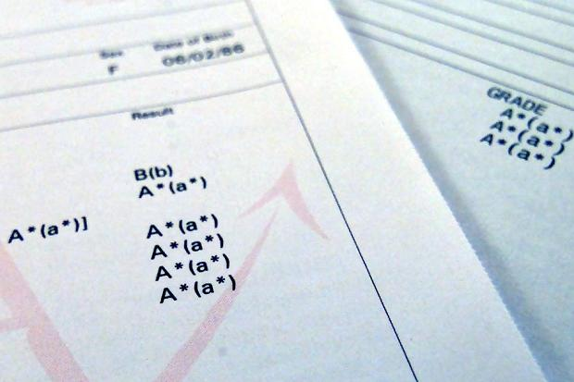

This guide aims to give valuable advice for examination results
received by candidates at St Thomas More Catholic School.

Please read this document carefully
and retain it for future reference

If there are ANY questions or problems, please contact the Exams Officer,
Miss Kingsley – exams@stm.beds.olicatschools.org

CONTENTS

CONTENTS 2
AFTER THE EXAMINATIONS 3
Notification of Results 3
STATEMENT OF RESULTS (Example) 4
POST RESULTS SERVICES 5
Reviews of Marking 5
Deadlines: 5
CERTIFICATES 6
APPENDICES 7
Appendix A 7
Appendix B 8

AFTER THE EXAMINATIONS

Notification of Results

GCE:
Results will be sent electronically via email to your School email account on Thursday 17th August 2023.

Staff will be available in school from 9:00am to deal with any specific exam / careers related guidance you may require. All students and parents are welcome to join in the celebrations in the Emmaus centre.

GCSE:
Results will be sent electronically via email to your School email account on Thursday 24th August 2023.

Staff will be available in school from 9:00am to deal with any specific exam / careers related guidance you may require. All students and parents are welcome to join in the celebrations in the Emmaus centre.

An envelope containing a hard copy of the Statement of Results and Awarding Body breakdowns will be available in school to collect on the day.

STATEMENT OF RESULTS (Example)

On results day you will receive a ‘Statement of Results’. THIS IS NOT YOUR FINAL CERTIFICATE. The statement lists ALL the exams you have taken.

A capital letter indicates an OVERALL grade. Endorsement grades are listed in the last column in the format P = Pass / M = Merit / D = Distinction.

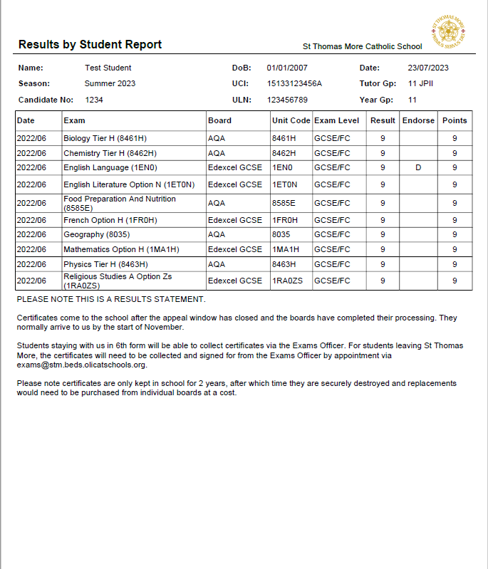

POST RESULTS SERVICES

Reviews of Marking
All Reviews of Marking (ROMs) should first be discussed with the relevant Head of Department and/or Subject Tutor who will advise on the viability of such a request. The “Review of Marking Form” should then be completed and signed (Appendix A). These forms will be made available to complete and collect on results day.

PLEASE NOTE – unless it is a priority review of marking, post results services forms will not be processed until 1st September.

In the school’s experience, it is unusual for marks to change upwards by more than a marginal amount. However, the school reviews the marks that your child and others have achieved and will advise candidates if we feel there is an anomaly and that the paper should be reviewed. If we are concerned about results received for a particular subject, the school itself will request a review of marking of all those papers (with the candidate’s consent)

Review of Marking categories are as follows:
SERVICE 1 CLERICAL CHECK
This service included the following checks:
That all parts of the script have been marked. The totalling of marks. The recording of marks. The application of any adjustments. The application of grade thresholds. The application of any special consideration, where applicable (indicate on form). The outcome of the re-check will be reported along with a statement of the total marks awarded for each unit/component included in the enquiry. The target for completion is within 20 calendar days of exam board receiving request.
SERVICE 2 (Review of Marking)
This is a post-results review of the original marking to ensure that the agreed mark scheme has been applied correctly. The service is available for externally assessed components of both unitised and linear specifications.
The deadline for completion is within 30 calendar days of the awarding body receiving the request. This service will include:
➢ the clerical re-checks detailed in Service 1;
➢ a review of marking as described above;
➢ if requested, a copy of the reviewed script(s) for those units/components included as part of the Access to Scripts service. (If the nature of the unit/component is such that access to scripts cannot be arranged, such as externally assessed GCE AS and GCE A2 Modern Foreign Language Speaking tests, then a report/copy of the record sheet may be requested. Awarding bodies will advise centres of the mechanism by which reports may be requested.)
PRIORITY SERVICE 2P (Review of Marking)
This service is as Service 2. However, it is only available if a GCE A-level candidate’s place in higher education is dependent on the outcome.
Any applications not meeting these criteria will be treated as normal Service 2 requests. The deadline for completion is within 18 calendar days of the awarding body receiving the request.
ATS (Access to Script)
A photocopy or the original of the student’s script.

Deadlines:
Exam Board | Service 1 | Service 2P | Service 2 | ATS
Exam Board | DEADLINE | DEADLINE | DEADLINE | DEADLINE
Exam Board | 28-Sep-23 | 24-Aug-23 | 28-Sep-23 | 28-Sep-23
Exam Board | Clerical Check | Priority Mark Review | Mark Review | Access to Scripts

CERTIFICATES

Certificates are received in school early November and will available for collection by appointment to leavers by the end of the Autumn term. Students who move into 6th Form can collect their certificates from the Examinations Office.

JCQ regulations state that certificates should be kept for 12 months. If they remain uncollected they may be disposed of securely.

Certificates are important documents. Most educational institutions and potential employers will ask to see your original certificates. If you lose or fail to collect your Certificates, you will need to obtain duplicates from the relevant Awarding Body. The Awarding Bodies no longer replicate certificates unless you can prove they were destroyed by theft, fire or flood; they will only issue a Statement of Achievement. This currently costs in the region of £40.00 per ‘Statement of Achievement’.

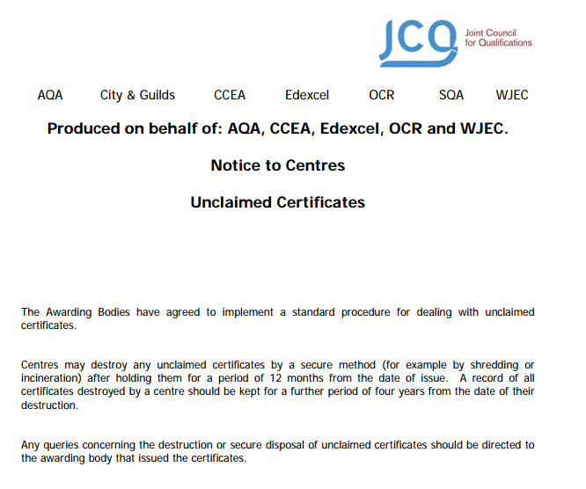

Appendix A
This is available on results day from the Emmaus centre
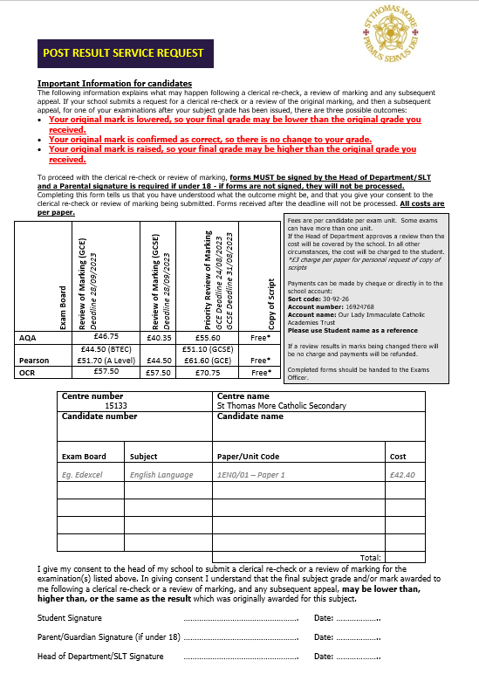

JCQ Appendix B



